EX. NO: 4

IMPLEME TATION OF VIGENERE CIPHER
AIM:
To implement the Vigenere Cipher substitution technique using C program.
ALGORITHM:
STEP-1: Arrange the alphabets in row and column of a 26*26 matrix.
STEP-2: Circulate the alphabets in each row to position left such that the first letter is
attached to last.
STEP-3: Repeat this process for all 26 rows and construct the final key matrix.
STEP-4: The keyword and the plain text is read from the user.
STEP-5: The characters in the keyword are repeated sequentially so as to match with
that of the plain text.
STEP-6: Pick the first letter of the plain text and that of the keyword as the row indices
and column indices respectively.
STEP-7: The junction character where these two meet forms the cipher character.
STEP-8: Repeat the above steps to generate the entire cipher text.
Program:
#include <stdio.h>
#include <string.h>
int main()
{
char text[100], key[100];
int i, j;
printf("Enter Plain Text (UPPERCASE): ");
scanf("%s", text);
printf("Enter Key (UPPERCASE): ");
scanf("%s", key);

int len = strlen(key);

printf("Encrypted Text: ");

for(i = 0, j = 0; text[i] != '\0'; i++, j++)
{
if(j == len)
j = 0;
printf("%c", ((text[i] - 'A') + (key[j] - 'A')) % 26 + 'A');
}
return 0;
}
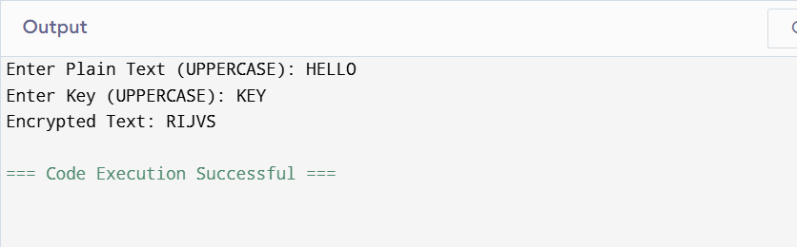
Result:
Thus the Vigenere Cipher substitution technique had been implemented successfully.

